Terraform Documentation is very nice. Below given the documentation link.

Terraform Documentation Link:- <https://developer.hashicorp.com/terraform>

Terraform Registry :- <https://registry.terraform.io/>

1. How terraform request will understand go to AWS ?
2. How terraform will authenticate the request ?
3. How we will login AWS account here.

**Terraform Work Flow**

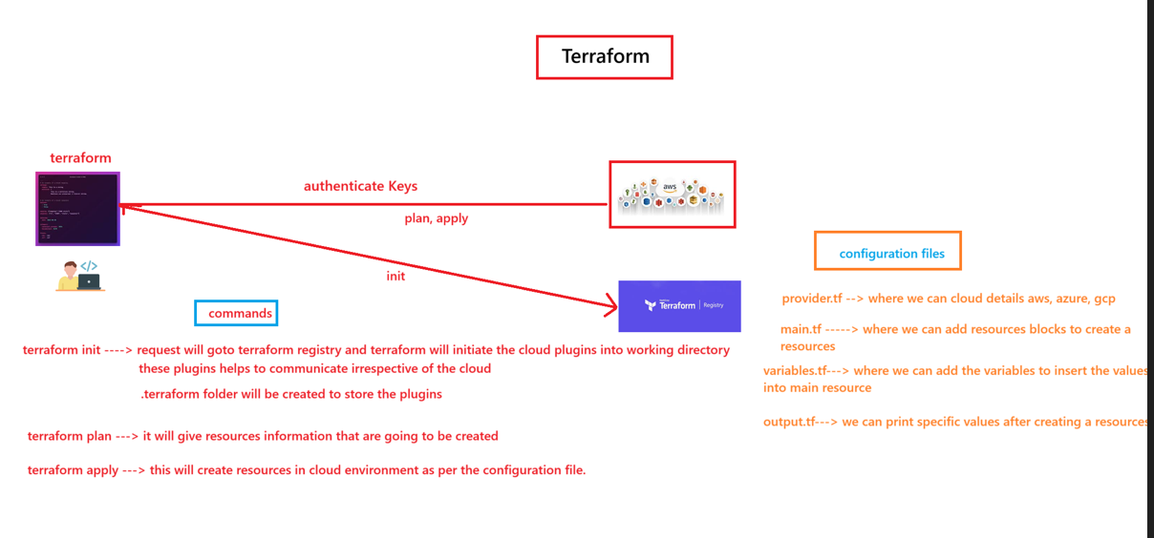

1. First when we call init than it will go to registry and check user wants for which cloud plugins. That’s are we are providing provider.tf

**Terraform Installation**

Follow steps from documentation.

Update Hashi Corp extension in VS Code.

**Practical**

1. Create 2 files inside your directory which is provider.tf and main.tf
2. Then Configure your keys using aws configure command in terminal.

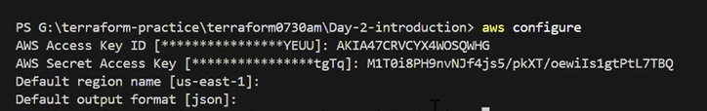

1. Which region you configured from that region you will get that EC2 EMI.
2. If we want to provide region then define the region in provider.tf like region = us-east-1
3. When we will execute terraform init then .terraform folder and terraform.lock file will generate.

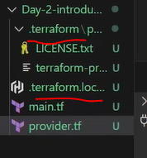

1. When we will execute terraform plan than it will show what are change need to update in aws. In this command another file will create which is terraform.state file which keeps all the informations related to resources. This file contains metadata related to resourses. If we will execute same file again than it will no change. State file will track our changes.

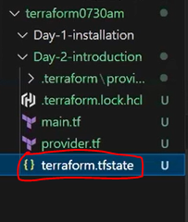

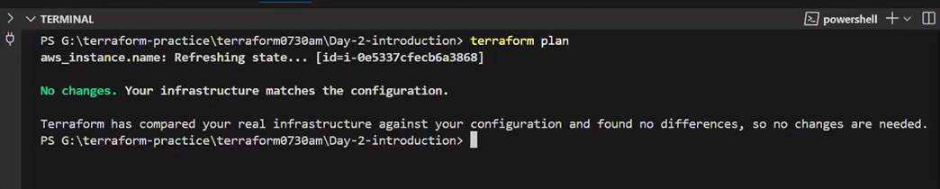

1. Go to registry url and click aws than provider latest version will came.

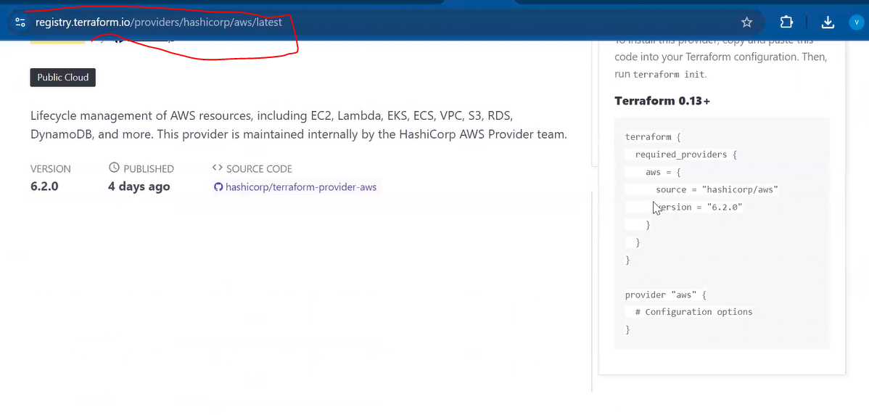

1. In terraform lock file automatically provider latest version will update. If we want to override than we need to update below code in provider.tf file. We need to update this one is mandatory. Due to this lock file we can’t modify the provider version otherwise it will affect for existing version changes.

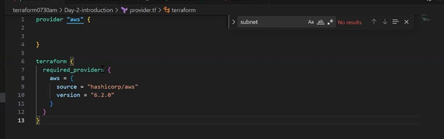

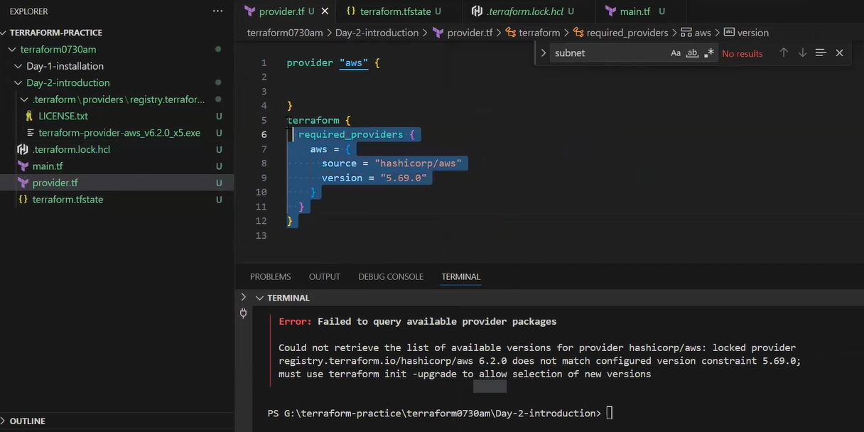

First we updated as latest 6.2.0 after few days we are trying to degrade to 5.69.0 than its not possible. If we want to change explicitly than we will use be command. Than version change will happen hand lock fole update to which version we are provided

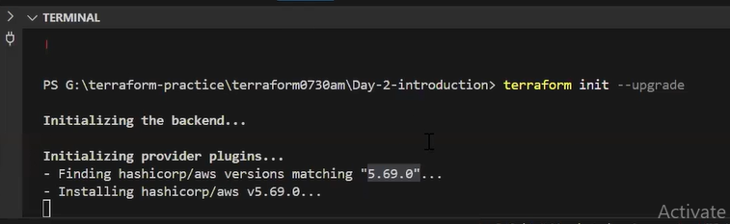

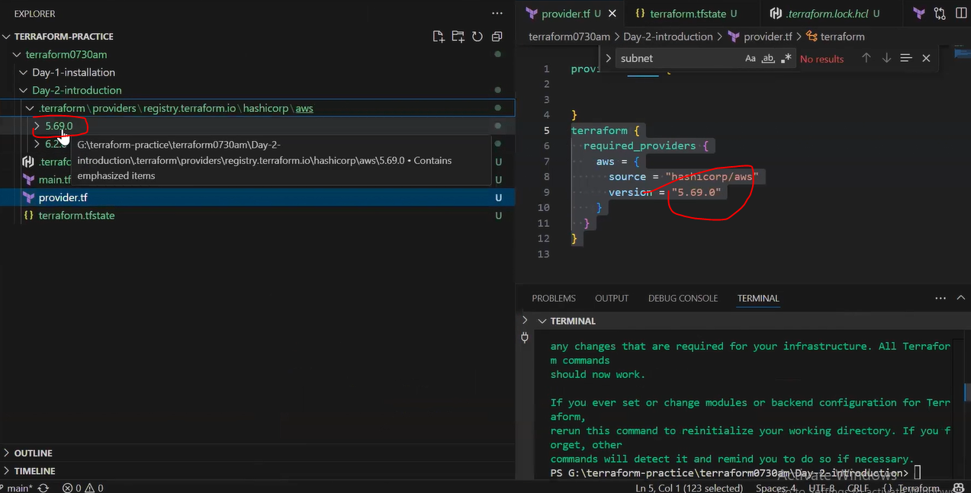

If we will remove code from provider.tf than it will call the which version in lock file . it will not call the latest version.

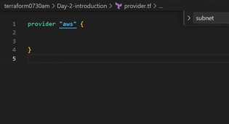

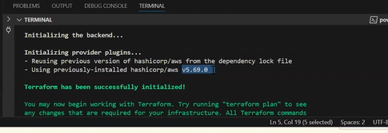

1. If we will modify any thing inside provider.tf than we will execute terraform init. Thi is for one time.
2. Those files are not required in remote level aand add .gitignore in parent level.

